|  |
| --- |
| AppIcon.png |
| Home Affairs |
| A Step by Step |
|  |
| **Weylin Renison** |
| **11/17/2013** |

|  |
| --- |
|  |

Table of Contents

About 3

Step By Step Guide 4

Logging In 4

Creating a New User 5

Creating an ID Document 7

Creating a Passport 9

Creating a Death Certificate 11

Finding this user manual again 13

Hold the Ctrl key and click on a chapter if you wish to jump to that chapter straight away.

# About

This application was developed by Weylin Renison

Home Affairs v1.0

Credits to Open Source External Libraries

# Step By Step Guide

## Logging In

To log in simply enter your correct user name and password, then click the Log In button.

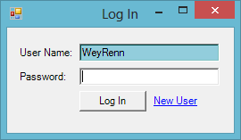

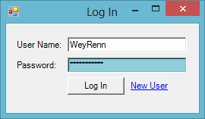

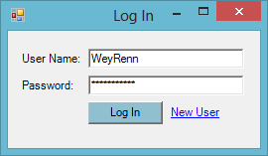

You will now be taken to the main screen if your credentials are valid.

## Creating a New User

To create a new user, from the log in screen click on the text "New User".

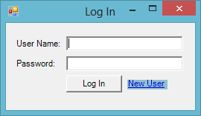

You will be taken to the new user registration screen, enter all your details and choice a username you would like to use to log into the system.

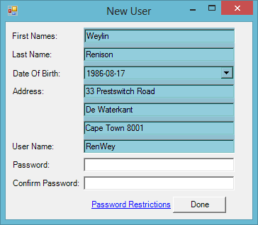

Now choice an appropriate password to log in with, keep in mind there are restrictions by clicking on the text "Password Restrictions" you can read them.

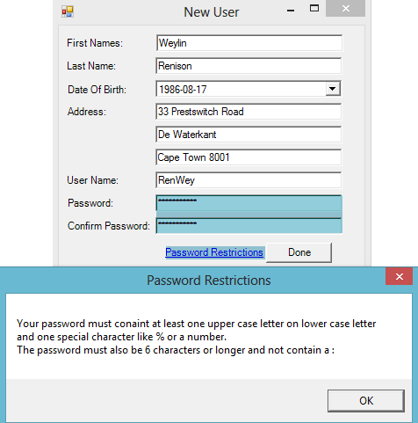

Now Click the done button, you should now be presented with a message that confirms you account has been created. You can now immediately use your account to log in. (see Logging In). 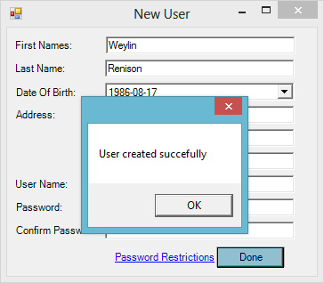

## Creating an ID Document

On the main screen make sure the ID Document tab is selected.

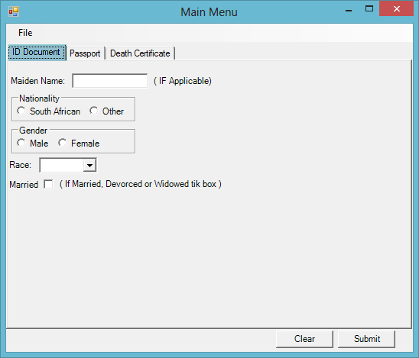

You can now proceed to complete your particulars, if you are married, divorced or widowed make sure to tick the Married box and complete your partner's particulars.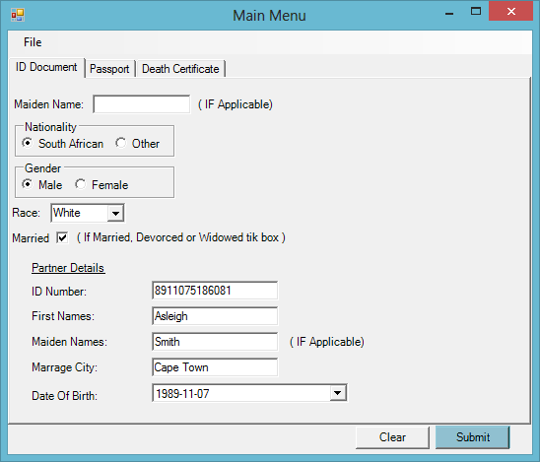

You can now click the submit button. If at any point you would like to clear your particulars and start over click the clear button next to the submit button.

You will now be presented with your ID document. If you would like to print it click on the printer icon in the bottom right hand corner.

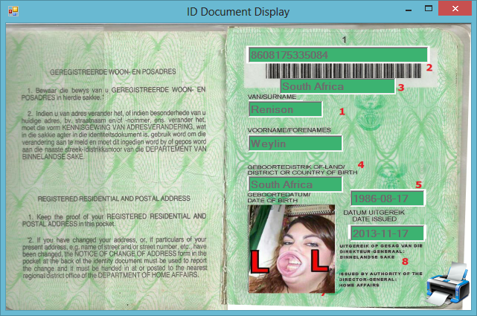

Your ID number will now be displayed on the ID Document tab and will never change, if you would like to view the document again click the View Document button.

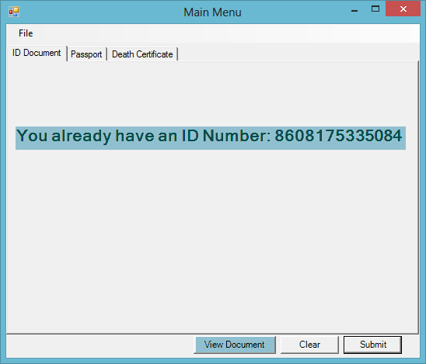

## Creating a Passport

On the main screen ensure the Passport tab is selected. Note that your ID number is already inserted for you.

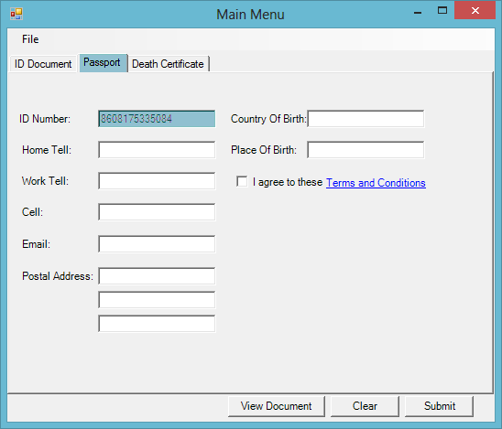

Complete your particulars and make sure to tick the agree to terms and conditions box. If you would like to read the terms and conditions click on the terms and conditions text.

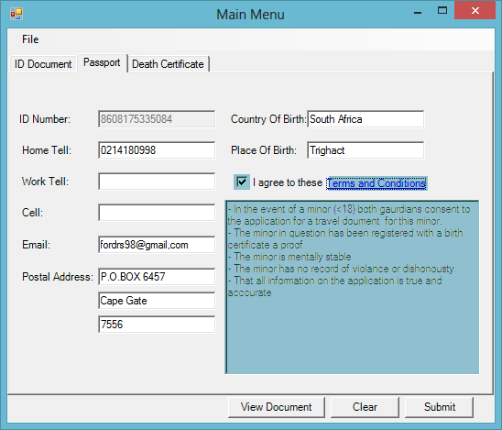

Now click on the submit button and you will be presented with your passport document.

If at any point you would like to clear your particulars entered click on the clear button next to submit.

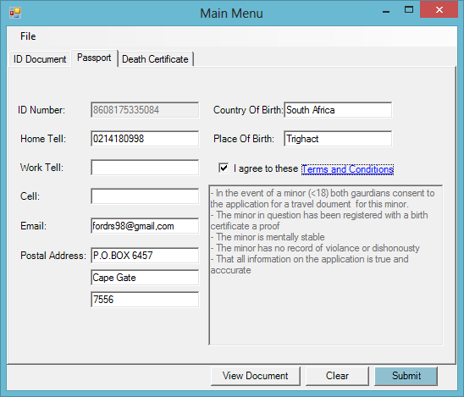

If you would like to print the document click on the printer icon in the bottom right corner.

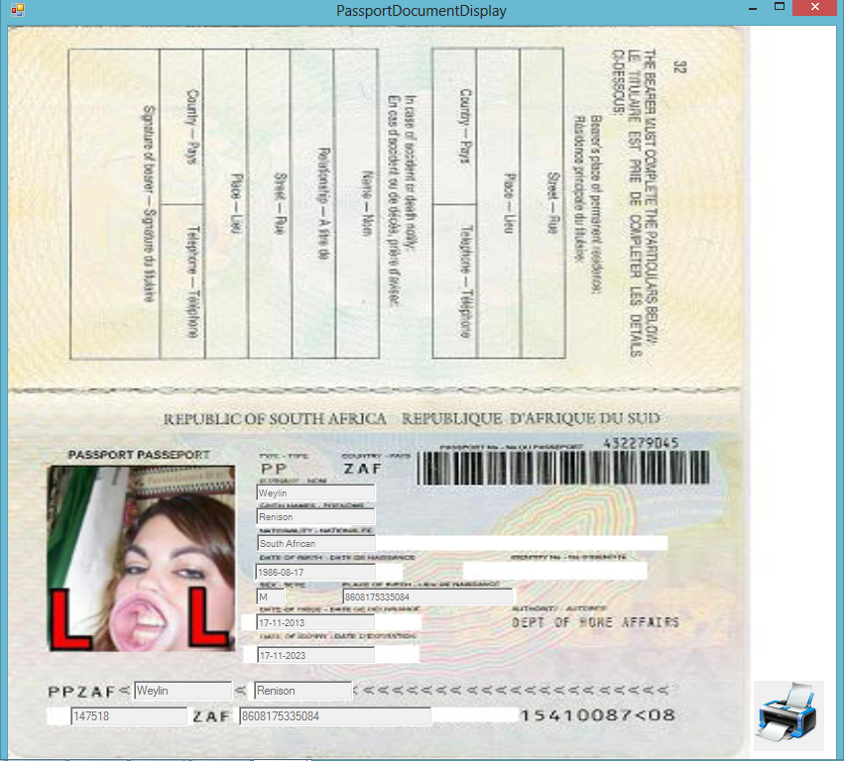

If you would like to view the document again click on the view document button next to the clear button.(Ensure the passport button is selected)

## Creating a Death Certificate

On the main screen ensure the Death Certificate tab is selected.

Then complete all the particulars of the deceased.

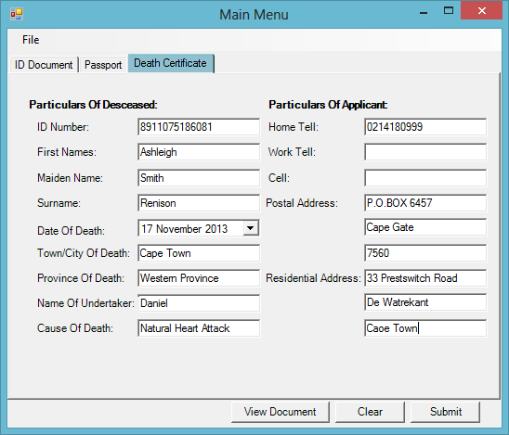

You can now click submit, you will be presented with the death certificate. If at any point you would like to clear the particulars you have entered and start over click on the clear button next to submit.

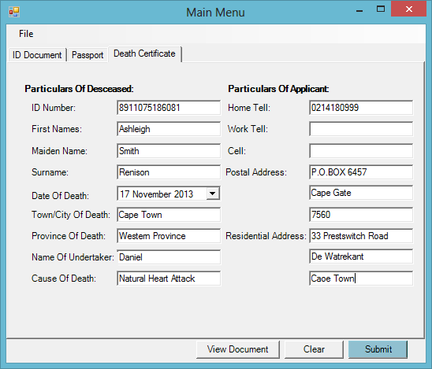

If you would like to print the document click on the printer icon in the bottom right of the screen.

If you would like to save the document click on the save icon in the bottom left corner of the screen.

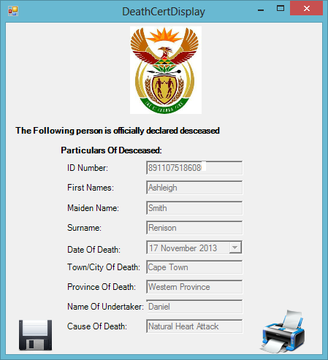

# Finding this user manual again

Click on the Help menu then on Help or press the F1 key on your keyboard.

